**CHAPTER 1**

**INTRODUCTION**

**1.1 INTRODUCTION**

Antenna is an interface between radio waves propagating in space and electric current moving in metal conductor. Through the years there have been several modifications in structure and shape of the antenna. One such evolution is microstrip patch antenna.

A microstrip patch antenna usually means an antenna fabricated using microwave techniques on printed circuit board. They are mostly used at microwave frequencies.

A microstrip patch antenna configuration consists of a cuboidal substrate and consists of a flat rectangular sheet which can be used as a transmitter or receiver (patch) mounted over a large rectangular sheet called ground plane. The ground and patch are made of copper, coated with either Tin or Aluminium and they are photo etched on dielectric material which acts as a substrate.

Microstrip patch antennas have multiple advantages such as low profile, low volume, fabrication cost is low hence they can be mass manufactured. They are capable of supporting multiple frequency bands and support dual polarization viz., linear and circular polarization. They are robust. Integration of MIC is easy.

Microstrip antenna plays a pivotal role in wireless applications and in global positioning systems due to its light weight and low planar configuration. The impedance bandwidth of a patch antenna is the distance between patch and the ground plane.

The antenna is designed for 3.05 GHz and 5.25 GHz frequencies which are used for radar transceiver and Wi-Fi applications respectively. The most commonly employed microstrip patch antenna is rectangular patch antenna. Patch antenna has the ability to have polarisation diversity.

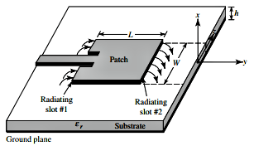

**Figure 1.1 Fringing fields in patch antenna**

Antenna is a device used for radiating or receiving radio waves. In other words, the antenna is the transitional structure between free space and a guiding device (used to transport electromagnetic energy from the transmitting source to the antenna or from the antenna to the receiver). In addition to the receiving of transmitting energy, an antenna in an advanced wireless system is usually required to optimize or attenuate the radiation energy in some directions and suppress in others.

Thus the antenna must also serve as a directional device in addition to the probing device. It may be a piece of conducting wire, an aperture, a patch, an assembly of elements (array), a reflector, a lens, and so forth. For wireless communication systems, the antenna is one of the most critical components. A good design of the antenna can relax system requirements and improve overall system performance.

**1.2 ANTENNA PARAMETERS**

To describe the performance of an antenna, definitions of various parameters are necessary. Some of the parameters are interrelated and not all of them need to be specified for complete description of the antenna performance.

**1.2.1 POLARISATION**

Polarization is defined as “the property of an electromagnetic wave describing the time varying direction and relative magnitude of the electric field vector”. It may be classified as linear, circular or elliptical. If the vector that describes the electric field at a point in space as a function of time is always directed along a line, the field is said to be linearly polarized. If the electric field traces is an ellipse, and field is said to be elliptically polarized. If the point traces a circle as a function of time, then it is said to be circularly polarized.

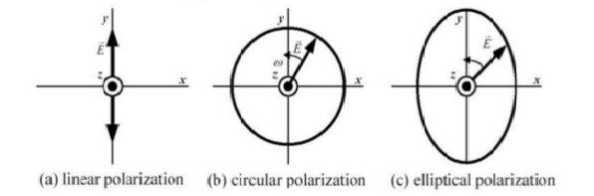

a) Linear polarization b) Circular polarization c) Elliptical polarization

**Figure 1.2 Three Types of polarization**

**1.2.2 RADIATION PATTERN**

An antenna radiation pattern is defined as “a mathematical function or a graphical representation of the radiation properties of the antenna as a function of space coordinates”. The radiation property of most concern is the two-or three- dimensional spatial distribution of radiated energy as a function of the observer’s position along a path or surface of constant radius. Various parts of a radiation pattern are measured to as lobes, which may be sub classified into major or main, minor, side and back lobes. A radiation lobe is a “portion of the radiation pattern bounded by regions of relatively weak radiation intensity”. A major lobe is defined as “the radiation lobe containing the direction of maximum radiation”.

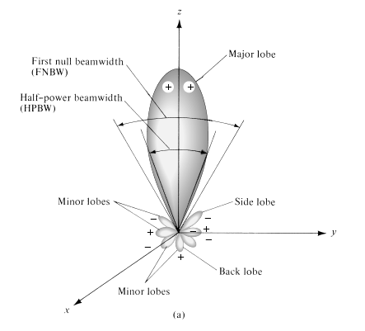

**Figure 1.3 Radiation lobes and beamwidths of an antenna pattern**

A minor lobe is any directions except a major lobe. A side lobe is “a radiation lobe in any direction other than the intended lobe”. A back lobe is “a radiation lobe whose axis makes an angle of approximately 180 degrees with respect to the beam of antenna”.

**1.2.3 GAIN**

Gain of an antenna (in a given direction) is defined as “the ratio of the intensity, in a given direction, to the radiation intensity that would be obtained if the power accepted by the antenna were radiated isotropically. The radiation intensity corresponding to the isotropically radiated power is equal to the power accepted (input) by the antenna divided by 4π”. When the direction is not stated, the power gain is usually taken in the direction of maximum radiation. In equation form this can be expressed as,

Gain = 4π $\frac{Radiation intensity}{Total input power}$ = 4π $\frac{U(θ,φ)}{P}$

**1.2.4 DIRECTIVITY**

Directivity is a fundamental antenna parameter. It is a measure of how ‘directional’ an antennas radiation pattern is. An antenna that radiates equally in all directions would have effectively zero directionality. In mathematical form, it can be written as,

D = $\frac{U}{U_{0}}$ = $\frac{4πU}{P_{rad}}$

**1.2.5 VSWR**

The parameter VSWR is a measure that numerically describes how well the antenna is impedance matched to radio or transmission line it is connected to. VSWR stands for Voltage Standing Wave Ratio and is also referred to as Standing Wave Ratio (SWR). It is a measure of how efficiently radio-frequency power is transmitted from a power source, through transmission line, into a load. This Voltage Standing Wave Ratio is a measure used to determine the severity of standing waves in a transmission line. The mathematical expression of Voltage Standing Wave Ratio is,

VSWR = $\frac{V_{max}}{V_{min}}$ = $\frac{1+\left|Γ\right|}{1-\left|Γ\right|}$

**1.2.6 RETURN LOSS**

In telecommunications, return loss is the loss of power in the signal returned or reflected by a discontinuity in a transmission line or optical fiber. This discontinuity can be a mismatch with the terminating load or with a device inserted in the line. This ratio is usually expressed in decibels (dB). Return loss was majorly occurred due to the two causes: discontinuities and impedance matches. The mathematical expression is,

Return loss = -20 log10 |Γ| (dB)

**1.3 ANTENNA**

An antenna is a specialized transducer that converts radio-frequency (RF) fields into alternating current (AC) or vice-versa. Antennas play an important role in the operation of all radio equipment. They are used in wireless local area networks, mobile telephony and satellite communication. Antennas can be omnidirectional, directional or arbitrary.

**1.4 WORKING OF ANTENNA**

1. Electricity flowing into the transmitter antenna makes electrons vibrate up and down it, producing radio waves.
2. The radio waves travel through the air at the speed of light.
3. When the waves arrive at the receiver antenna, they make electrons vibrate inside it. This produces an electric current that recreates the original signal.

**1.5 MICROSTRIP PATCH ANTENNA**

A patch antenna is a type of radio frequency antenna with a low profile which can be mounted on a flat planar surface. It consists of a flat rectangular conducting sheet which can be used as a transmitter or receiver (patch) mounted over a large rectangular conducting sheet called ground plane. Multiple patch antennas on the same substrate called array of micro strip antennas can be used to make high gain.

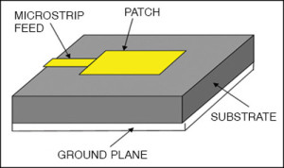

**Figure 1.4 A typical microstrip patch antenna**

**1.5.1 TYPES OF PATCHES**

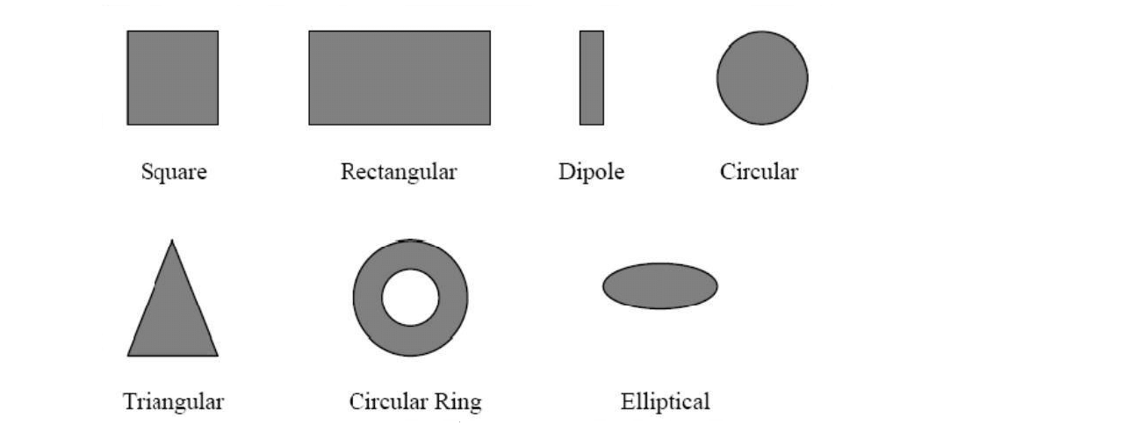

**Figure 1.5 Types of patches**

The commonly available shapes of patch antenna are rectangular, circular, dipole, triangular, square and elliptical.

**1.5.2 ADVANTAGES**

Microstrip patch antennas are low profile, comfortable to planar and non-planar surfaces, simple and inexpensive to manufacture, robust when mounted on rigid surfaces. Here the feed lines and matching network are fabricated simultaneously. It is capable of dual and triple frequency operation. In addition, by adding loads between the patch and the ground plane, such as pins and varactor diodes, adaptive elements with variable resonant frequency, impedance, polarization, and pattern can be designed. Another major advantage in microstrip patch antennas is ease of installation and supports dual polarization.

**1.5.3 DISADVANTAGES**

Major operational disadvantages of microstrip antennas are their low efficiency, low power, high Q (sometimes in excess of 100), poor polarization purity, poor scan performance, spurious feed radiation and very narrow frequency bandwidth, low impedance bandwidth , low gain, extra radiation occur from its feed and junctions, large ohmic losses in the feed arrays, low power handling capacity, excitation of surface waves, polarization purity is difficult to achieve, complex feed structures require high performance arrays and finally the spurious radiation exists in various microstrip based antennas such as microstrip patch antenna, microstrip slot antenna and printed dipole antenna.

**1.5.4 APPLICATIONS OF MICROSTRIP PATCH ANTENNA**

The microstrip patch antennas are well known for their performance and their robust design, fabrication and their extent usage. Microstrip antennas are spreading widely in all the fields and areas and now they are booming in the commercial aspects due to their low cost of the substrate material and the fabrication**.** Microstrip patch antennas have several advantages over conventional microwave antennas and therefore are widely used in many practical applications.

Microstrip patch antennas are used in mobile satellite communication system, direct broadcast television, GPS system, missiles and telemetry, UHF Patch antennas for space, used as feed elements in coaxial system and also used for wireless LAN’s.

**1.6 FEEDING TECHNIQUES**

There are many configurations that can be used to feed microstrip antennas. The four most popular types are as follows

1) Microstrip line feed.

2) Coaxial line feed.

3) Aperture coupled feed.

4) Proximity coupled feed.

A feed line is used to excite to radiate by direct or indirect contact.

**1.6.1 MICROSTRIP LINE FEED**

Microstrip line feed is one of the easier methods to fabricate as it is a just conducting strip connecting to the patch and therefore can be consider as extension of patch. It is simple to model and easy to match by controlling the inset position. However, the disadvantage of this method is that as substrate thickness increases, surface wave and spurious feed radiation increases which limit the bandwidth.

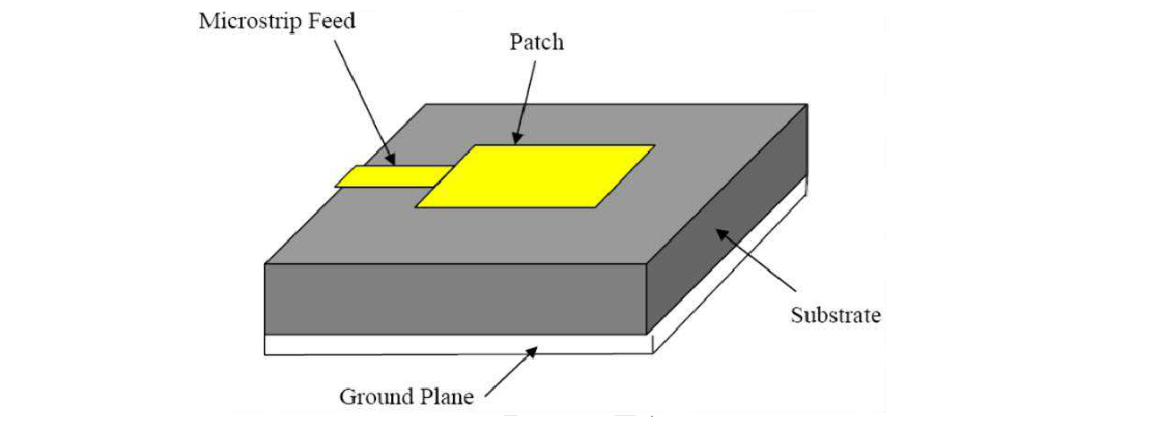

**Figure 1.6 Microstrip feed line**

In this type of feeding technique, a conducting strip is connected directly to the edge of the microstrip patch. The conducting strip is smaller in width as compared to the patch and this kind of feed arrangement has the advantage that the feed can be etched on the same substrate to provide a planar structure.

**1.6.1.1 INSET FEED:**

Since this typically yields high input impedance, we would like to modify the feed. Since the current is low at the ends of a half-wave patch and increases in magnitude toward the center, the input impedance (Z=V/I) could be reduced if the patch was fed closer to the center. One method of doing this is by using an inset feed. This method can be used to tune the input impedance to the desired value.

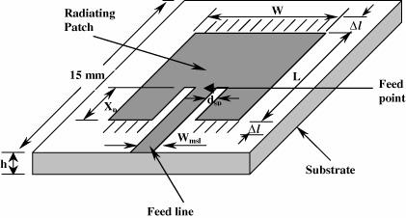

**Figure 1.7 Inset Feed**

**1.6.2 COAXIAL LINE FEED**

The coaxial probe feeding is a very common technique used for feeding microstrip patch antennas. The inner conductor of the coaxial cable extends through the dielectric and is soldered to the radiating metal patch, while the outer conductor is connected to the ground plane. The advantage of this feeding scheme is that the feed can be placed at any desired location on the patch in order to match cable impedance with the antenna input impedance. The main aim to use probe feeding is it enhances the gain, provides narrow bandwidth and impedance matching.

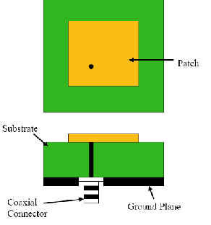

**Figure 1.8 Coaxial Line feed**

**1.6.2.1 ADVANTAGES**

* Easy of fabrication.
* Easy to match.
* Low spurious radiation.

**1.6.2.2 DISADVANTAGES**

* Narrow bandwidth.
* Difficult to model specially for thick substrate.
* Possess inherent asymmetries which generate higher order modes which produce cross – polarization radiation.

**1.6.3** **APERTURE COUPLING**

Aperture coupling consist of two different substrates separated by a ground plane. On the bottom side of lower substrate there is a microstrip feed line whose energy is coupled to the patch through a slot on the ground plane separating two substrates. This arrangement allows independent optimization of the feed mechanism and the radiating element. Normally top substrate uses a thick low dielectric constant substrate while for the bottom substrate; it is the high dielectric substrate. The ground plane, which is in the middle isolates the feed from radiation element and minimizes interference of spurious radiation for pattern formation and polarization purity.

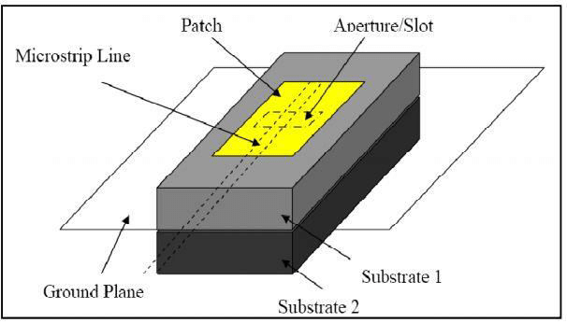

**Figure 1.9 Aperture coupling**

In this type of feed technique, the radiating patch and the microstrip feed line are separated by the ground plane. Coupling between the patch and the feed line is made through a slot or an aperture in the ground plane. The advantage of aperture couple feed is that it allows independent optimization of feed mechanism element.

**1.6.4 PROXIMITY COUPLED FEED**

This type of feeding technique is also called as the electromagnetic coupling scheme. Two dielectric substrates are used such that the feed line is between the two substrates and the radiating patch is on top of the upper substrate. The main advantage of this feed technique is that it eliminates spurious feed radiation and provides very high bandwidth, due to overall increase in the thickness of the microstrip patch antenna.

Proximity coupling has the largest bandwidth, has low spurious radiation. However, the fabrication is difficult. Length of feeding stub and width-to-length ratio of patch is used to control the match.

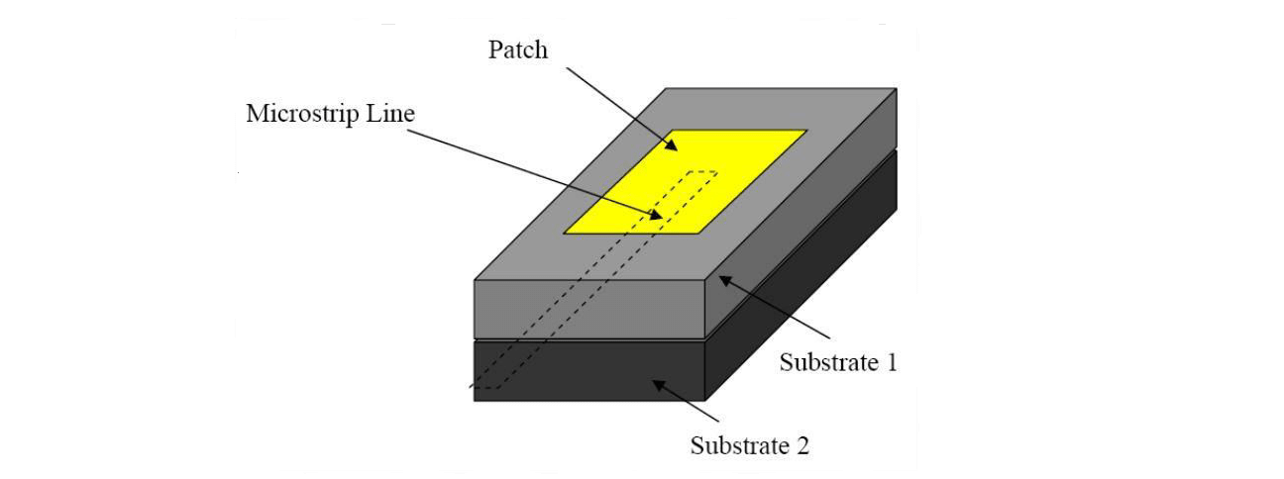

**Figure 1.10 Proximity coupled feed**

**1.7 CHARACTERISTICS OF DIFFERENT FEED TECHNIQUES**

Different feeding techniques can be classified into two categories contacting and non-contacting. In the contacting method, the RF power is fed directly to the radiating patch using a connecting element such as a microstrip line. In the non-contacting scheme, electromagnetic field coupling is done to transfer power between the microstrip line and the radiating patch.

|  |  |  |  |  |
| --- | --- | --- | --- | --- |
| **Characteristics** | **Microstrip line feed** | **Coaxial line feed** | **Aperture coupled feed** | **Proximity coupled feed** |
| Spurious Feed Radiation | More | More | Less | Minimum |
| Reliability | Better | Poor due to soldering | Good | Good |
| Ease of fabrication | Easy | Soldering and drilling required | Alignment  Required | Alignment  Required |
| Impedance matching | Easy | Easy | Easy | Easy |
| Bandwidth | 2-5% | 2-5% | 2-5% | 13% |

**Table 1.1 Comparison of different feed techniques**

**1.8 ORGANISATION OF THE THESIS**

**Chapter 2** presents the literature review. The literature survey is based on the IEEE papers and journals where some of the base papers give the major impact and knowledge of doing this project.

**Chapter 3** outlines the features of the simulation software tool - HFSS and it presents the design and simulated measurements of the simple patch antenna on which the analysis is carried out in our project.

**Chapter 4** presents the design and simulation of the antenna.

**Chapter 5** presents the result and simulation outputs.

**Chapter 6** conclusion.

**Chapter 7** future works planned for near future.

**Chapter 8** reference papers used obtaining knowledge about the project work.

**CHAPTER 2**

**LITERATURE REVIEW**

The project literature review is based on the IEEE papers and journals, where some of the base papers which gives the major impact and knowledge of doing this project are given below.

• **Comparison of Performance Characteristics of Rectangular, Square and Hexagonal Microstrip Patch Antennas:(Vinita Mathur, Dr. Manish Gupta)**

The recent developments in the era of low-cost and compact communication systems have largely been due to the advent of small weight and size antennas that are capable of giving good output characteristics over a large frequency range attracted much attention towards the research because of these reasons. In this paper, the comparison of three widely popular designs of microstrip patch antennas has been done .Designing begins with design of patches and then its analysis. Rectangular, square and hexagonal microstrip patch antenna are analyzed using HFSS and comparison is made between them in addition to low computational complexity, enhanced connectivity and high speed. Modern wireless communication networks also offer advantages such as low profile structures, light weight, gain must be high and compact size that assures reliability, mobility and good efficiency. The compact design of patch antenna is due to conventional microstrip fabrication technique.

• **Gain and Bandwidth Enhancement Techniques in Microstrip Patch Antennas – A Review: (Alok Kumar, Nancy Gupta, P.C. Gautam)**

Today antenna designer are playing more focus on microstrip patch antenna, because of its numerous advantages in field of communication, such as high reliability, light weight, easy of fabrication etc. But despite of its bountiful advantages, patch antenna also experience some drawbacks i.e. low gain and narrow bandwidth. These drawbacks can be overcome by taking care of some parameters in design of antennas. There are numerous designing factors affecting the radiating characteristics of antenna such as patch height, feeding techniques, substrate used in manufacturing of antenna etc. The paper is focused on various bandwidth enhancement techniques, parasitic patch elements, introduction of slots, dual feed, shorting pin, air gap and recently introduced concept of defective ground structure that enhances the gain and bandwidth of antenna without increasing its height.

• **Design & Analysis of Hexagonal Patch Antenna at 1.8GHz for**

**L-Band: (Maneesh Rajput)**

In this paper, we designed a hexagonal shape patch antenna for L-space band applications. After designing the antenna on 1.8GHz, we study and analyzed the results of both simulated and measured. For L-band, we use the dielectric substrate 4.2, loss tangent .0012 and having the substrate of height 2mm. The patch and ground plane dimensions are same for both antennas. The designed antenna on IE3d software at 1.8GHz frequency showing the bandwidth 52% return loss -22dB while the designed antenna on hardware base at 1.8GHz frequency showing the bandwidth 43.9% having return loss -27dB. All the other respective result i.e., VSWR, gain directivity, efficiency and 3D radiation for software design are shown.

• **Design of Ku-Band Hexagonal Microstrip Patch Antenna With Linear And Circular Polarizations (Kadiyam Suresh, Dr. P. Siddaiah)**

This paper presents two antennas, one is linearly polarized dual frequency hexagonal microstrip patch antenna and other is wide band circularly polarized hexagonal microstrip patch antenna. The presented antennas are designed for Ku band applications. Dual frequency is obtained by introducing a rectangular shaped slot on the hexagonal patch. Both antennas are simulated using HFSS 14.0 and performance measures of an antenna such as return loss, VSWR, axial ratio, peak gain and radiation pattern are measured.

• **Implementation of Octagonal and Hexagonal Microstrip Patch Antennas for UWB Applications (M. L. Naidu, Dr. B. Rama Rao,**

**Dr. C. Dharamraj)**

Ultra Wideband (UWB) communication systems have the advantages of very high bandwidth, fading minimization from multipath, and low power requirements. As per the standards of Federal Communications Commission (FCC), the UWB range is 3.1 GHz to 10.6 GHz. The Ultra Wideband (UWB) is rapidly advancing as a high data rate wireless communication technology. The Bandwidth of an antenna can be extended to high frequencies by adding an octagonal or hexagonal strip horizontally from the printed antenna and asymmetrically affix a conducting strip to the antenna. The paper describes the design of antenna to enhance the bandwidth by increasing the size of the strip monopole by different geometries. The geometry of the wide Octagonal strip monopole is a Octagon of side 'a=9mm' where as for the wide Hexagon monopole is a Hexagon of side ‘a=10mm’.The strips designed with a length of 23mm and gap 'd=3mm' between ground planes and strip for both the antenna geometries to achieve matching. The two printed monopole antennas are designed are etched onto a FR-4 epoxy substrate with an overall size of 45mm × 60mm ×1.6 mm.The proposed antennas is simulated by using Ansoft HFSS and tested by Vector Network Analyzer (E5071C) to obtain the results . The Hexagonal strip monopole is resonating at 5.5 GHz and UWB impedance bandwidth (S11 <–10 dB) ranges from 1.54 to 9.41GHz, while the Octagonal strip monopole is resonating at 5.5GHz and UWB impedance bandwidth (S11 <–10 dB) ranges from 1.3 to 5.65 GHz. The VSWR values for Hexagonal is 1.52:1 at 2.09GHz & for Octagonal it is 1.53:1 at 1.78GHz .The Bandwidth for Hexagonal is 7.87GHz, while for Octagonal is 4.35GHz.

• **Design and Analysis of Various Slots on Hexagonal Boundary Patch Antennas for Enhanced Gain(Kalpana Muvvala, R. Ramana Reddy and Naresh Kumar Darimireddy)**

Many antenna experts reported slotted microstrip patch antennas due to their compactness and integration in communication systems. Limitations of patch antennas are bandwidth and gain. Extensive research is carried out on patch antennas to improve gain and bandwidth. Many researchers had reported on regular shapes like square, rectangle, and circular patches. In this paper, a hexagonal boundary patch antenna is considered. In an attempt to increase the gain different shapes of slots on hexagonal patch antenna (HPA) are considered. From the results, it is evident that gain is increased with slots on patch antenna. The hexagonal slot on hexagonal patch antenna results in a gain of 6.8 dB. Simulation is carried out using HFSS software. Fabricated antenna is tested for practical results using vector network analyzer.

**CHAPTER 3**

**DESIGN OF MICROSTRIP PATCH ANTENNA**

The proposed antenna is realized on FR4 substrate with ɛr = 4.4 and thickness h=1.6mm. The antenna is simulated using CST software. Microstrip patch antennas are fed by a variety of methods. This antenna is designed by using transmission line feed as it is easier to fabricate.

**3.1 ANTENNA DESIGN**

For designing of a microstrip patch antenna, select the resonant frequency and a dielectric medium for which antenna is to be designed. The parameters to be calculated are as follows,

1. The width of the patch is calculated using the following equation

$W_{p}$ = $\frac{1}{2f_{r}\sqrt{ε_{0}μ_{0}}}$ $\sqrt{\frac{2}{ε_{r}+1}}$ = $\frac{v_{0}}{2f_{r}}\sqrt{\frac{2}{ε_{r }+1}}$ (3.1)

Where, $v_{0}$ is the free-space velocity of light

1. Determine the effective dielectric constant of the microstrip antenna using

$ε_{reff}$ = $\frac{ε_{r}+1}{2}$ + $\frac{ε_{r}-1}{2}$, $\frac{1}{\sqrt{(1+12\frac{h}{W_{p}} )}}$ (3.2)

1. Once W is found using, determine the extension of the length 3L using

$\frac{∆L_{p}}{h}$ = 0.412 $\frac{\left(ε_{reff}+ 0.3 \right)(\frac{W_{p}}{h}+ 0.264 )}{\left(ε_{reff}- 0.258\right)(\frac{W_{p}}{h}+ 0.8 )}$ (3.3)

1. The actual length of the patch can now be determined by using

$L_{eff}$ = L + 2△ (3.4)

$L_{p}$ = $\frac{1}{2f_{r}\sqrt{∈_{reff}}\sqrt{µ_{0}∈_{0}}}$- 2△ (3.5)

**3.2 SIMULATION SOFTWARE – CST**

CST Microwave Studio is a specialist tool for the 3D EM simulation of high frequency components. The unparalleled performance from CST makes it the first choice in leading R&D departments, since it enables the fast and accurate analysis of high frequency (HF) devices such as antennas, filters, couplers, planar and multi-layer structures and SI and MWS quickly gives insight into the EM behavior of your high frequency designs.

**3.2.1 FEATURES OF CST**

* Native graphical user interface based on Windows XP, Windows Vista, Windows 7 and Linux.
* Fast and memory efficient Finite Integration Technique.
* Extremely good performance due to Perfect Boundary Approximation (PBA) feature for solvers using a hexahedral grid. The transient and Eigen mode solvers also support the Thin Sheet Technique (TST).
* The structure can be viewed either as a 3D model or as a schematic. The latter allows for easy coupling of EM simulation with circuit simulation.

**3.2.2ADVANTAGES OF CST**

* Advanced ACIS based parametric solid modeling front end with excellent structure visualization.
* Feature based hybrid modeler allows quick structural changes.
* Structure templates for simplified problem description.
* Efficient calculation for loss-free and lossy structures.
* MPI Cluster parallelization via domain decomposition.
* Combined simulation with MPI and GPU acceleration.

**3.3 DESIGN OF PATCH ANTENNA**

A simple patch antenna is designed and developed using CST. The below structure indicates various parameters of patch antenna.

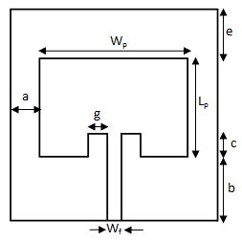

**Figure 3.1 Geometry of patch antenna**

The patch antenna is fed using transmission line as it is easier to fabricate. The feeding is given at the centre of patch element. Using the equations (1), (2), (3) and (4) a few parameters of the antenna was calculated and tabulated.

|  |  |
| --- | --- |
| **Parameters** | **Dimensions (in mm)** |
| WP | 29 |
| LP | 32 |
| A | 5.3 |
| G | 1.04 |
| C | 10.5 |
| B | 16 |
| E | 9 |
| Wf | 2.9 |

**Table 3.1 Specifications of patch antenna**

The various parameters involved in patch antenna are as follows

Wp = Width of patch antenna

LP = Length of patch antenna

a = Effective fringing width

Wf = Width of feed patch

c = Length of feed into patch

b = Feed length.

e = Effective fringing length

**3.3.1 PROCESSING STEPS**

## Accessing CST MWS

* 1. Select CST STUDIO SUITE 2016.
  2. The main window is shown in Figure 3.2.
  3. Click on “CST Microwave Studio” icon and click OK.

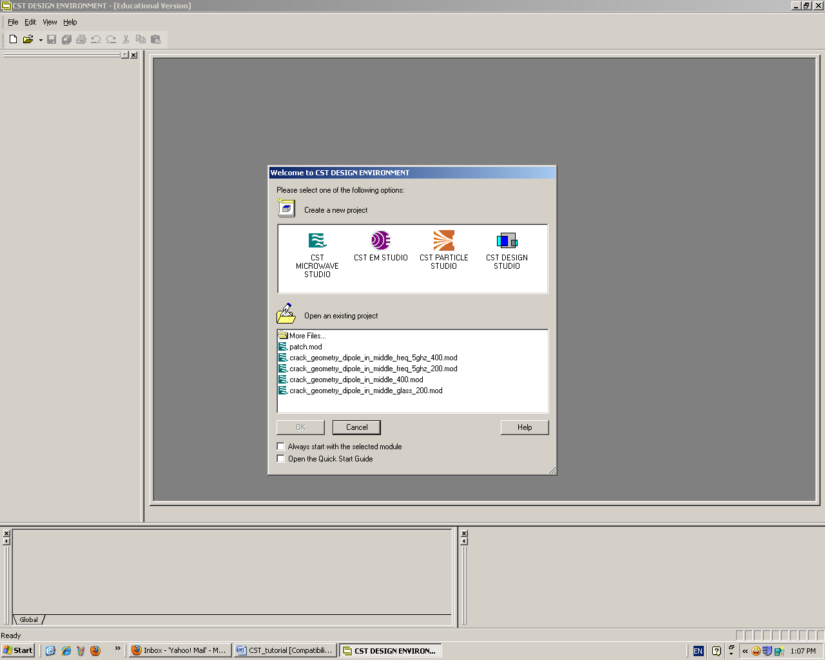

**Click Here then**

**click ok**

**Figure 3.2 CST main window**

* 1. A new pop-up window called “Create a New project” will appear. On the window shown in Fig. 2 project type is selected, i.e. Antenna (on planar substrate) in case of designing a microstrip patch antenna or Antenna in free space in case of designing a dipole or a monopole.

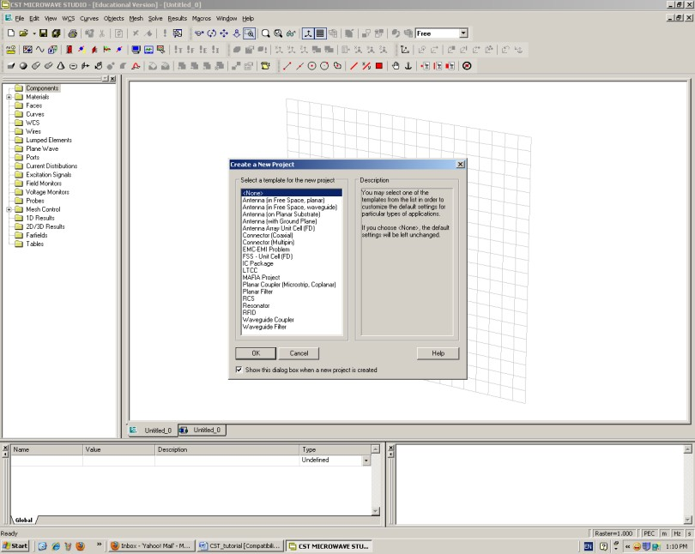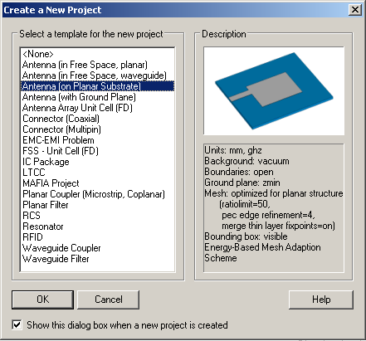

**Figure 3.3 Create new project window**

* 1. Confirmed by clicking OK on the main layout window as shown in Figure 3.4. A name is given to the project and saved.

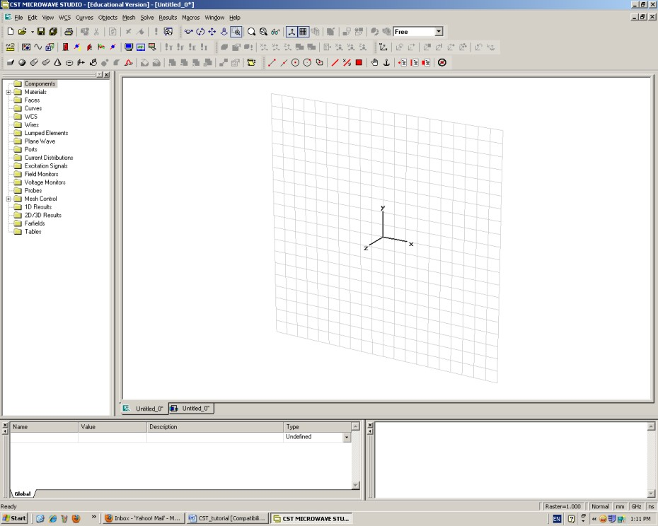

 **Figure 3.4 Main Layout window**

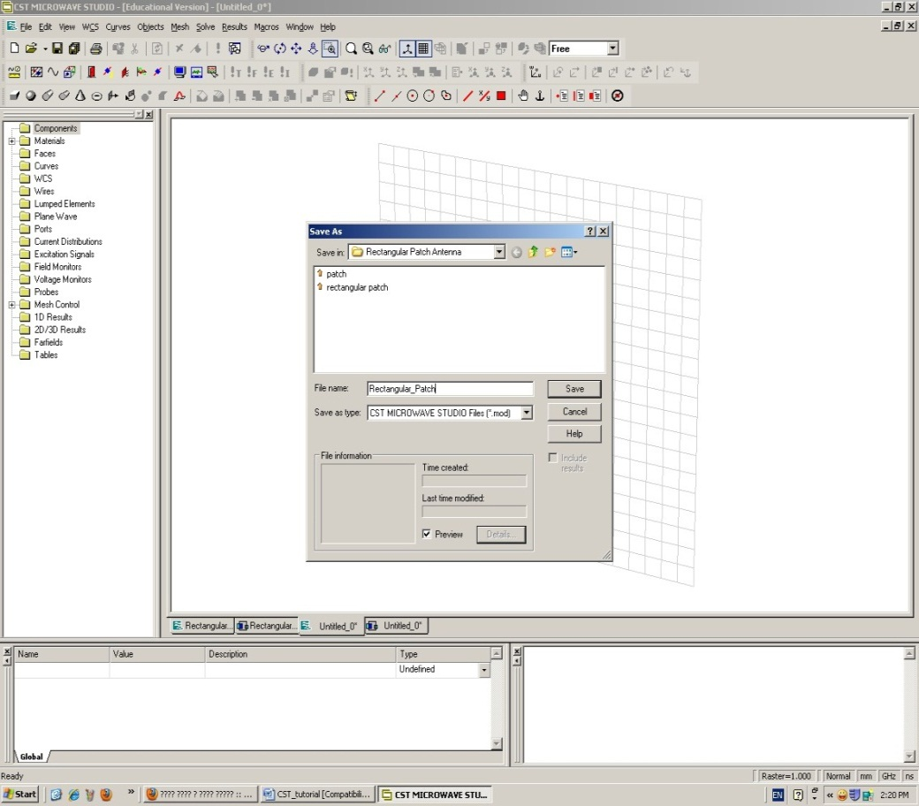

**Write the**

**project name here**

**Figure 3.5 Saving the working project**

**Rectangular Patch antenna design**

**Step 1 specifying the project units**

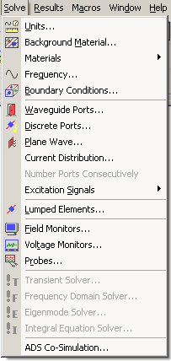Various SI units are assigned from thr Solve and Units option from the units window. The dimensions in mm, Frequency in GHz and time in ns as shown in Figure 3.6.

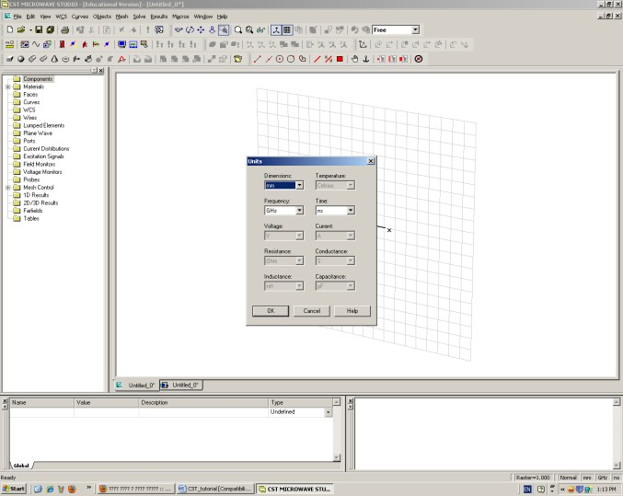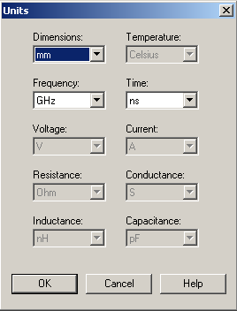

**Figure 3.6 Main units definition**

**Step 2 Assigning the Background material**

From main menu, Background Material is selected. New window called “Background properties” will pop up. Choose all parameters as the defaults as shown in Figure 3.7.

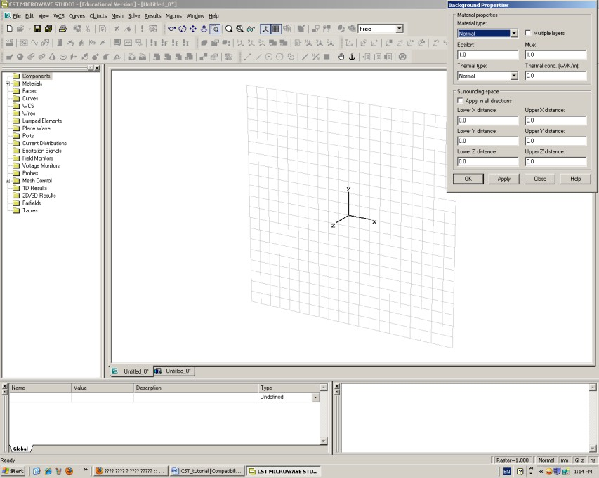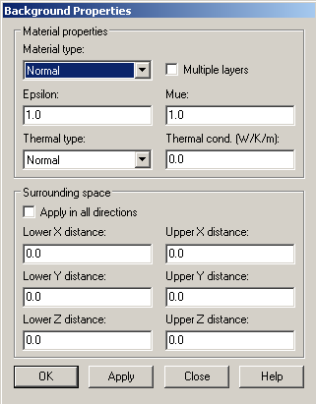

**Figure 3.7 Background material definition**

**Step 3 Antenna substrate definition**

Select > Objects > Basic Shapes > Brick. Click on the working area and drag the mouse and double click again to end the drawing mode. Now a new window called “Brick” will appear, from this window that shown in Figure 3.8 and adjust the required dimensions of the substrate, its name and its material. Adjust the substrate dimensions by changing *Xmin*, *Xmax, Ymin* and *Ymax*.

For the substrate material we need to change it to RT 5880 (εr=2.2) to do that click on the material select box and choose “ Load from material library”, then select the materials as been shown in the following figure 3.8.

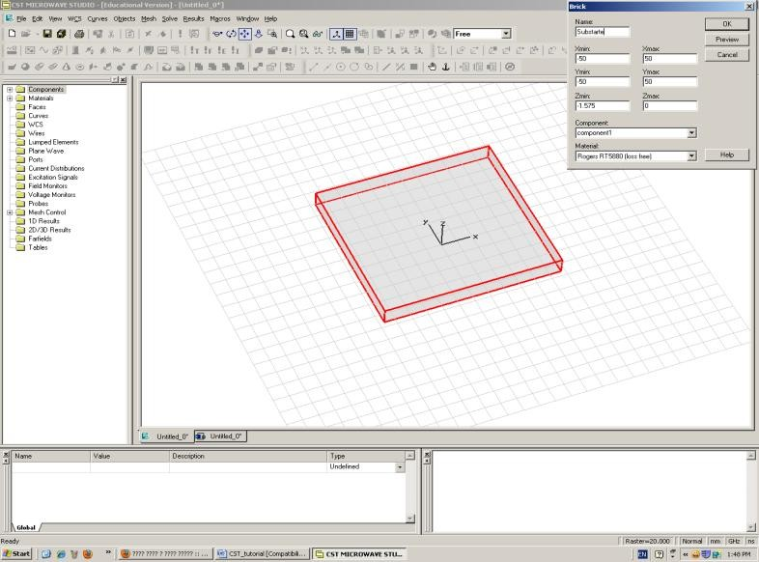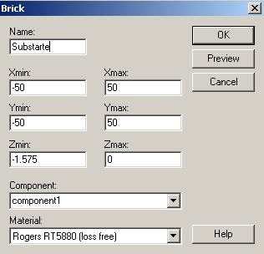

**Click here to**

**change the dimensions**

**Click here to**

**assign the**

**substrate material**

**Figure 3.8 Substrate definition**

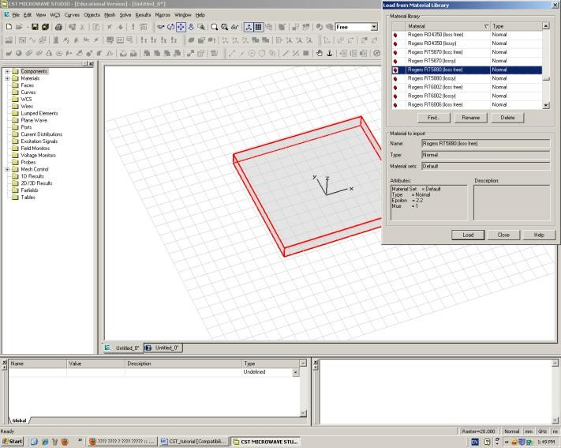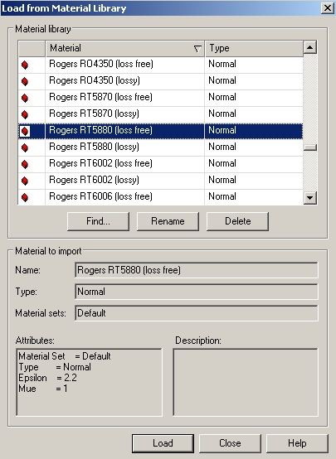

**Figure 3.9 Changing the Material of the substrate to RT 5880**

**Step 4 Antenna ground definition**

For the antenna ground create another brick “same as stated before” with a very thin thickness ( 0.1 mm) as shown in Figure 3.10 and change its material to copper.

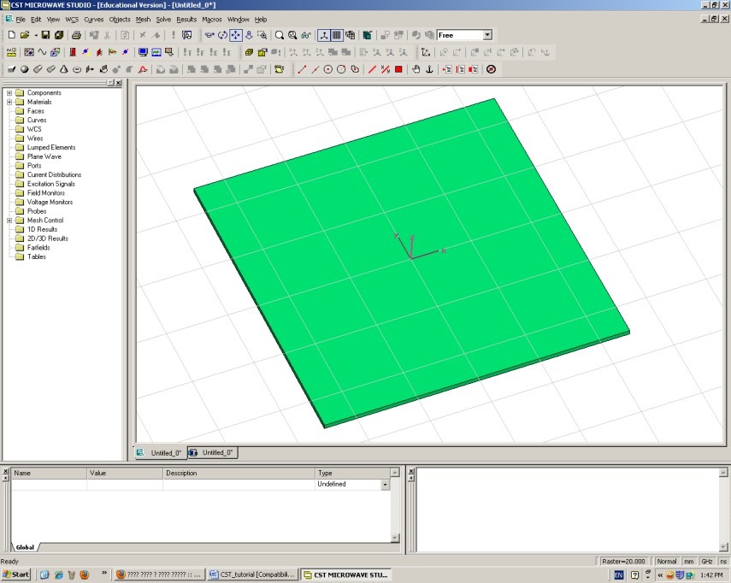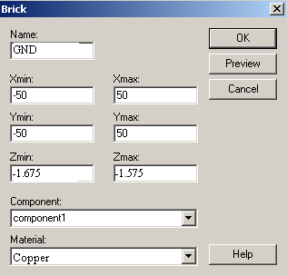

**Figure 3.10 Adding the ground plane of the antenna**

**Step 5 Drawing the radiating patch**

To draw a rectangular patch create another brick with the following parameters *Xmin* , *Xmax* , *Ymin* and *Ymax*. Assign its material to be copper as shown in Figure 3.11.

**Step 6 Drawing inset feed slot**

Create a brick with the following parameters *Xmin*, *Xmax,* *Ymin* and *Ymax*. Assign its material to be copper as shown in Figure 3.12.

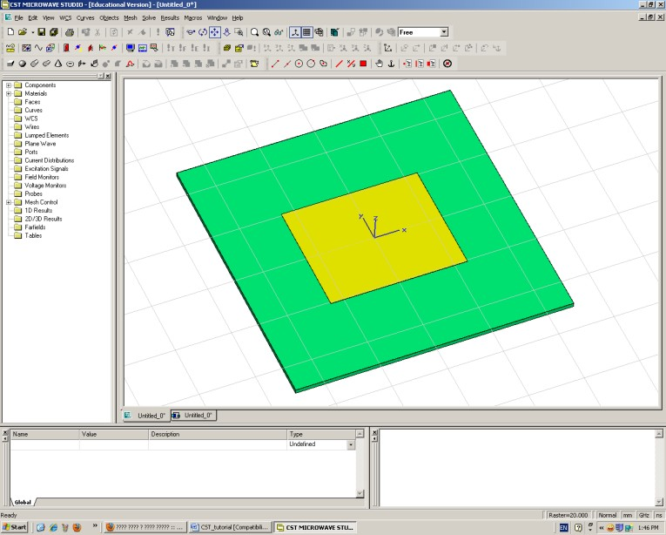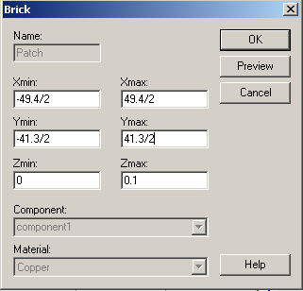

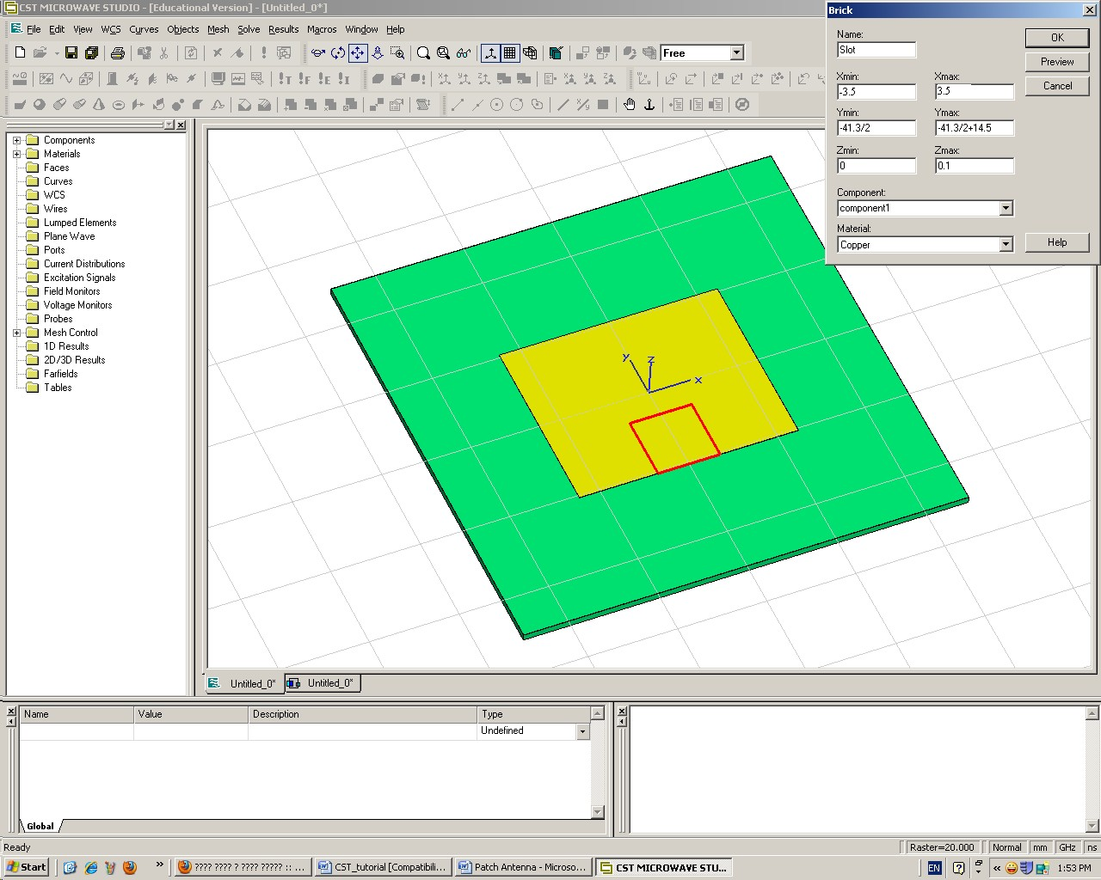 **Figure 3.11 Drawing the radiator patch**

**Figure 3.12 Drawing the inset feed slot**

**Step 7 Cutting the inset feed slot from the patch**

1. Click on “***Component1”*** to show all the components.
2. Click on patch to select it.
3. Click on “Boolean subtract (-)” icon from the toolbar
4. Click on slot and press enter key, see Figure 3.13.
5. Window shows up as seen in Figure 3.14.

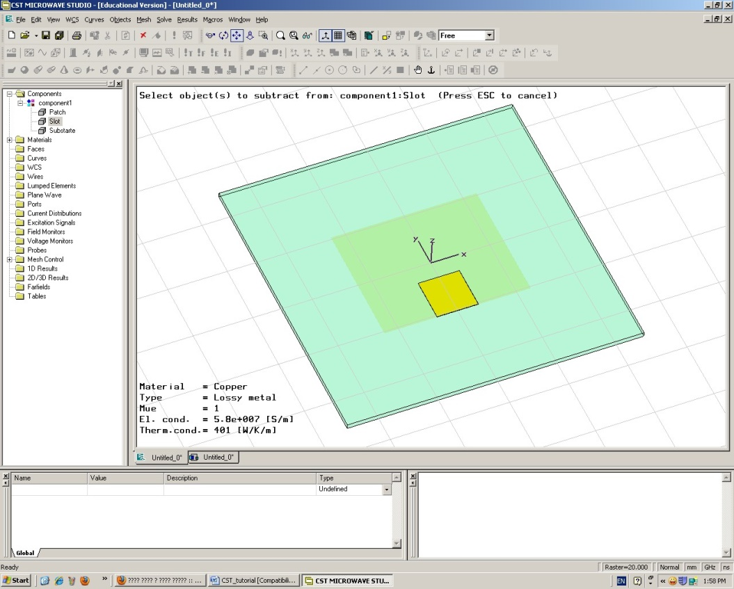

**Select slot**

**Figure 3.13 Selection of inset feed slot area to be cut**

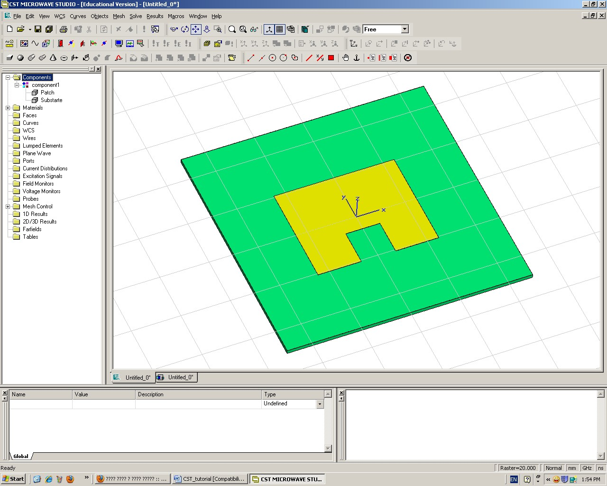

**Figure 3.14 Cutting the inset feed slot from the patch**

**Step 8 Drawing the 50 ohm feed line**

Again create a brick with the parameters *Xmin* , *Xmax*, *Ymin* ,and *Ymax*. Select the copper material as shown in Figure 3.15.

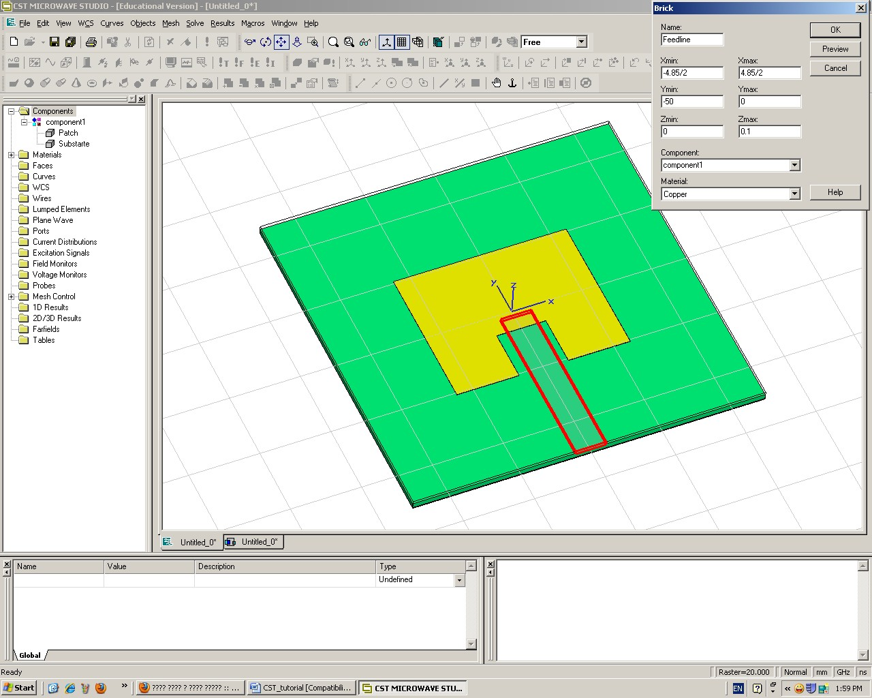

**Figure 3.15 Drawing the 50 ohm feed line**

**Step 9 Merging the feed line with the patch**

1. From the left pane under *“Component 1”* sub-menu click on *Feedline* then hold the *ctrl* key in the keyboard and click on *Patch* to select both of them.
2. From the toolbar click on “Boolean add (+)”, see Figure 3.16.
3. Now they are merged together and become one component as shown in Figure 3.17.

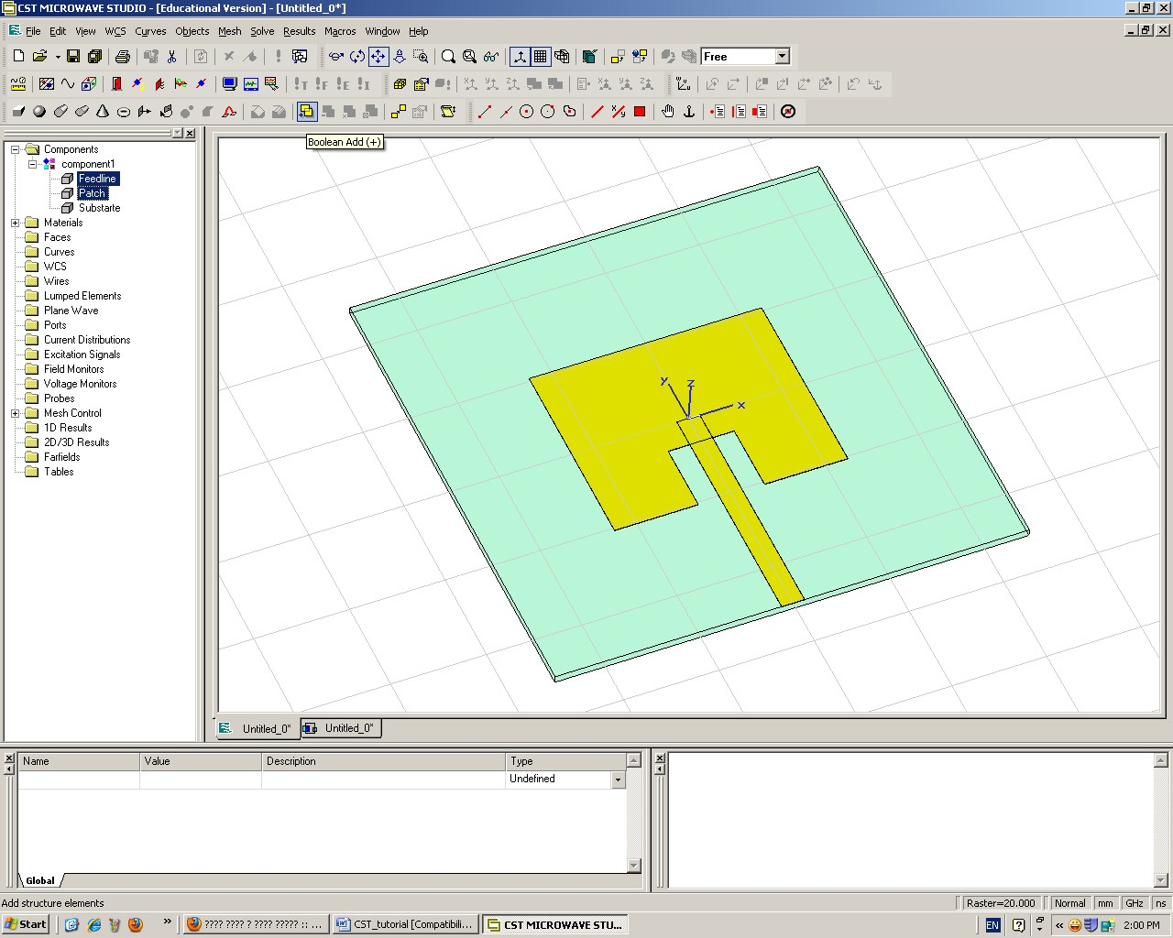

**Boolean Add**

**icon**

**Select**

**feedline and Patch**

**Figure 3.16 Merging the feed line with the patch**

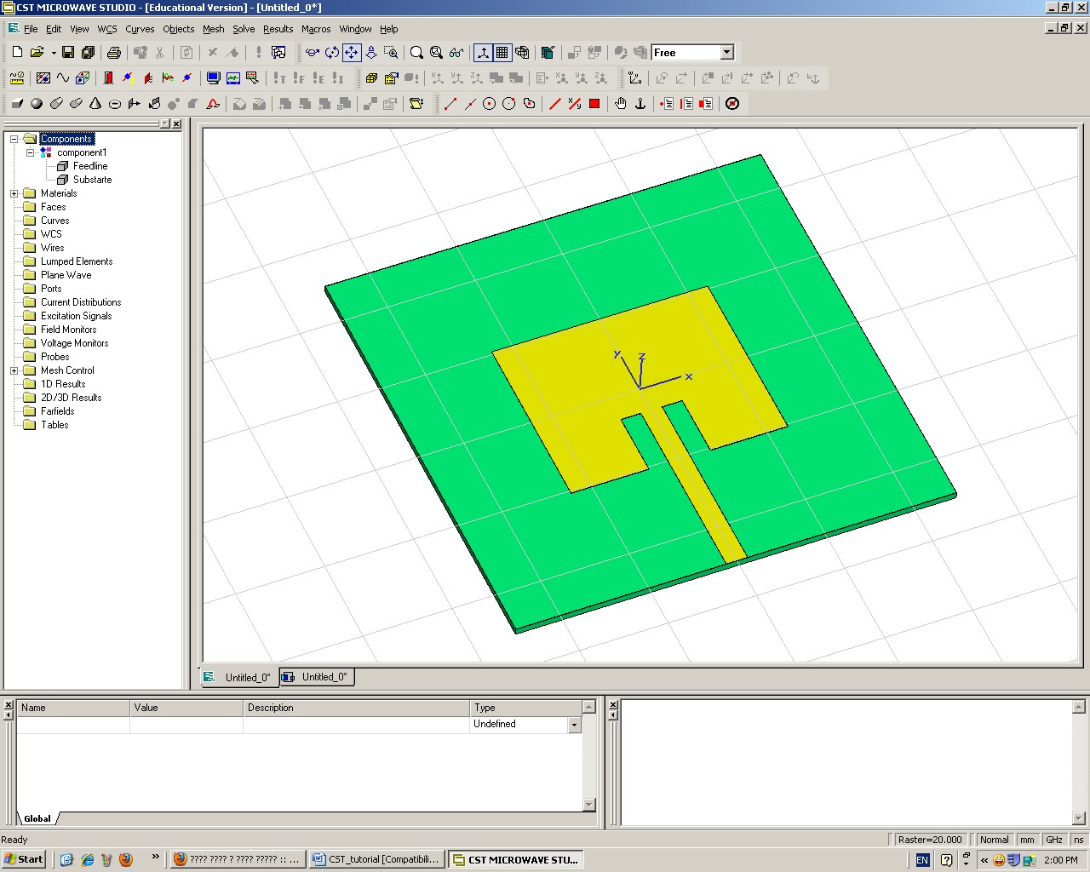

**Figure 3.17 The feed line and the patch after merging**

**Step 10 Defining the wave port for antenna**

1. From main menu select > Solve > waveguide ports or by click on waveguide ports icon in the toolbar.
2. Formulate *waveguide* port window select *Normal* to be *Y.*
3. Select free in the position box and enter the following dimensions for the wave port: *Xmin* , *Xmax* , *Zmin* and *Zmax.*
4. Check “free normal position” in position box and change *Ypos to be -50* as shown in Figure 3.18.
5. Click ok to see port 1 defined as shown in Figure 3.19.

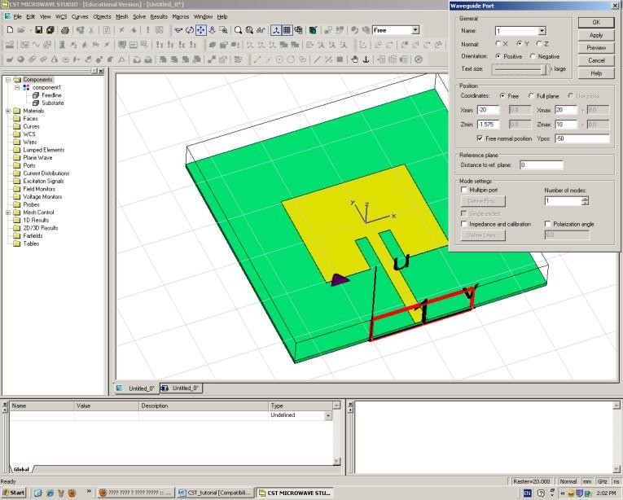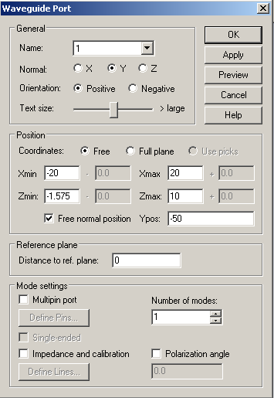

**Check free**

**normal position**

**Select**

**Free**



**Select Y**

**Figure 3.18 Definition of the wave port**

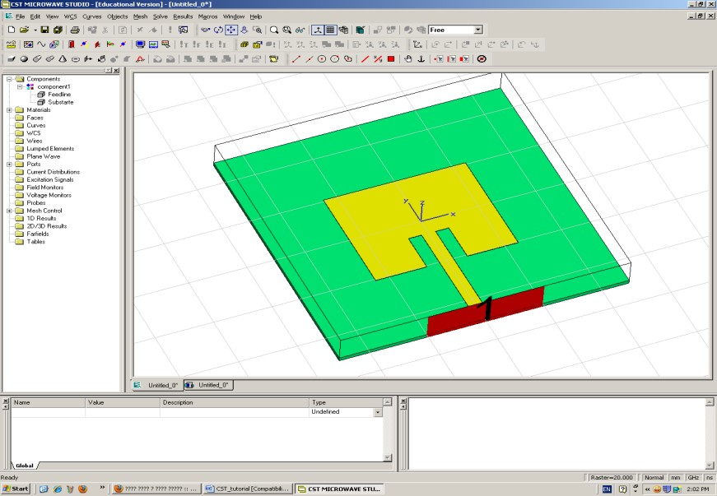

**Figure 3.19 Definition of the wave port**

**Step 11 Defining the simulation frequency range**

1. From main menu select > Solve > Frequency or by click on frequency range icon in the toolbar.
2. Enter the frequency range of simulation as *Fmin* and *Fmax.* Then click OK.



**Figure 3.20 Definition simulation frequency range**

**Step 12 Adding radiation pattern and surface current to your simulation results**

1. From main menu select > Solve > Field Monitors or click on field monitors icon in the toolbar.
2. From Monitor window select *Farfield / RCS* for plotting the radiation pattern and type the monitoring frequency. Then click apply as shown in Figure 3.21.
3. To plot the surface current distribution select *H-field/Surface current* and type the monitoring frequency then click apply.

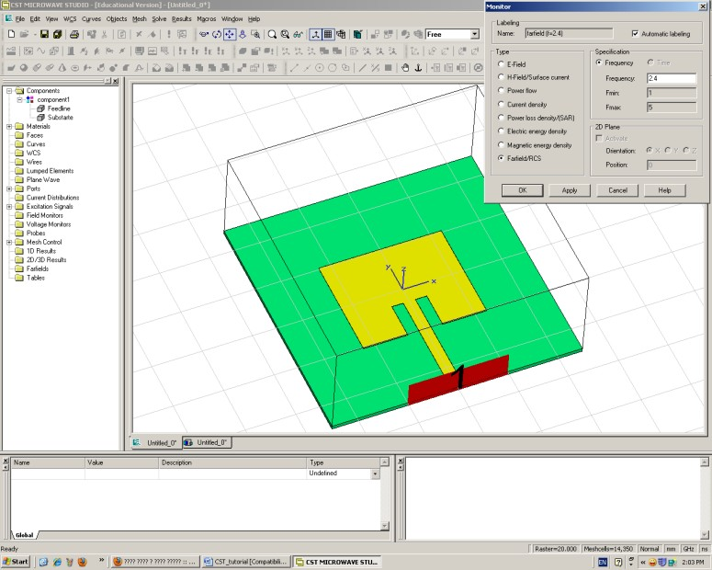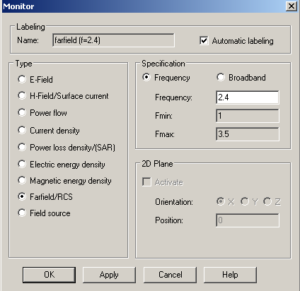

**Monitoring**

**frequency**

**Field**

**monitor icon**

**Figure 3.21 Adding radiation pattern and surface current to the simulation results**

## Step 13 Running the simulation

1. From main menu select > Solve > Transient solver or by clicking on Transient solver icon in the toolbar.
2. Form transient solver window the solver accuracy can be adjusted “the error margin” as shown in Figure 3.22.

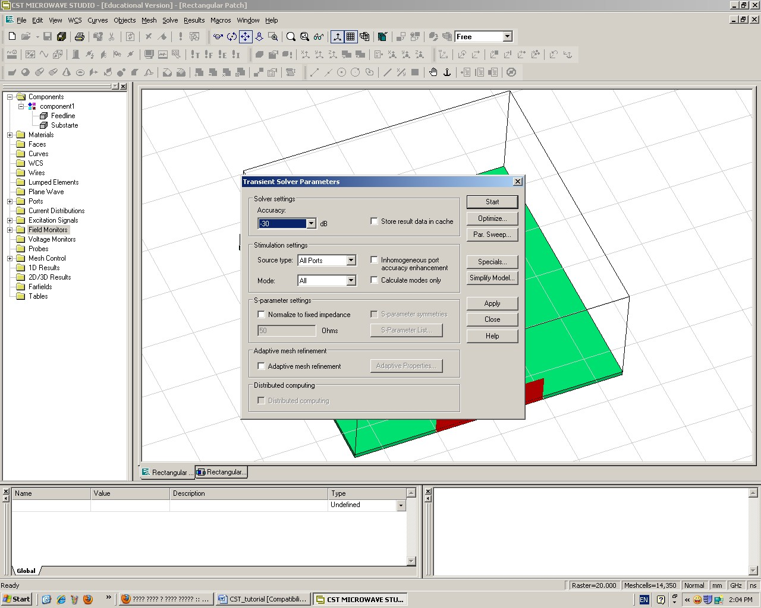

**Transient**

**solver icon**

**Figure 3.22 Running the transient solver**

**Step 14 Displaying the simulation results**

* 1. To show the S- parameter curves (i.e. linear, dB, phase, smith chart) ,click on *1D Results* then select the curve that needs to be displayed as shown in Figure 3.23.
  2. To show the current distribution plots, From the left pane click on *2D/3D Results* then select Surface current > h-fields as shown in Figure 3.24.
  3. To show the radiation pattern plots, From the left pane click on *2D/3D Results* then select Farfields > farfield as shown in Figure 3.25.

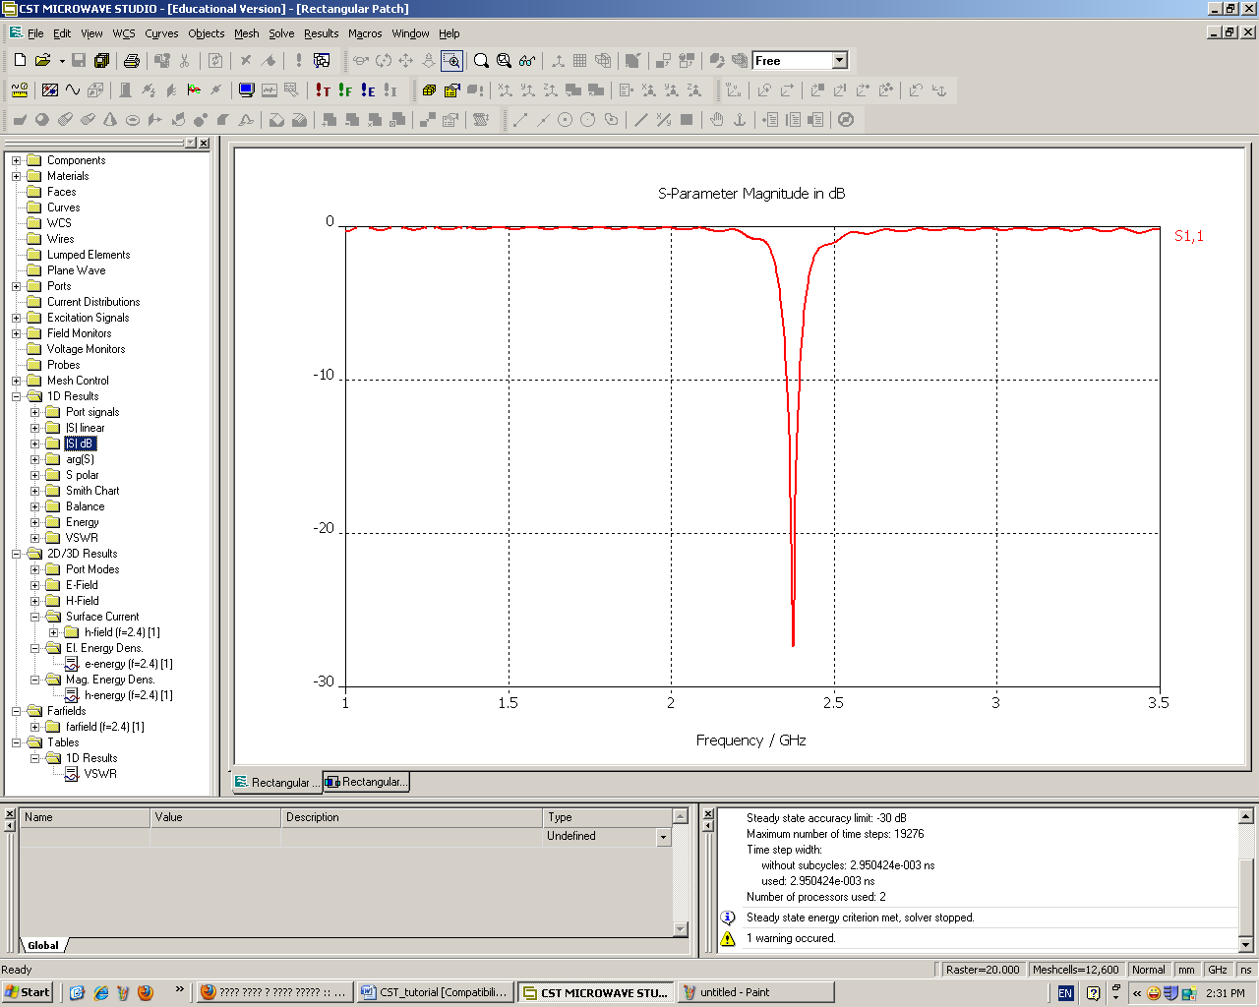

**Display S11**

**in dB**

**Figure 3.24 Displaying S-parameter curves**

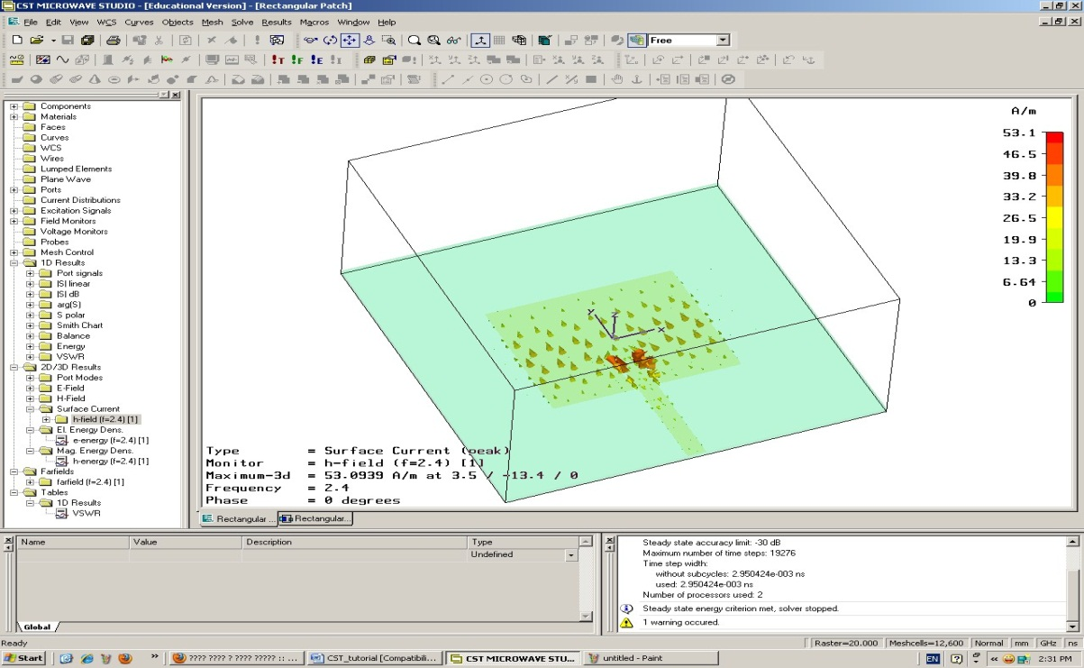

**curren distribution**

**Figure 3.24 Displaying current distribution plot**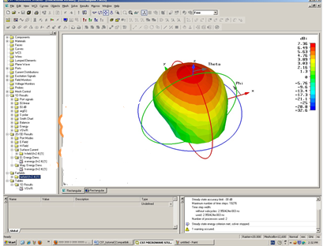

**Figure 3.25 Displaying radiation patterns plots**

**Step 15 Displaying the post processing results**

1. To show some post processed results (i.e. VSWR, Z-parameters, group delay) go to the main menu > Template based post processing as shown in Figure 3.25.
2. From Template based post processing window select the graph you want to display. Then click Evaluate as shown in Figure 3.26.
3. From the left pane select 1D Results > Tables > 1 D results > VSWR to show the plot as shown in Figure 3.27.

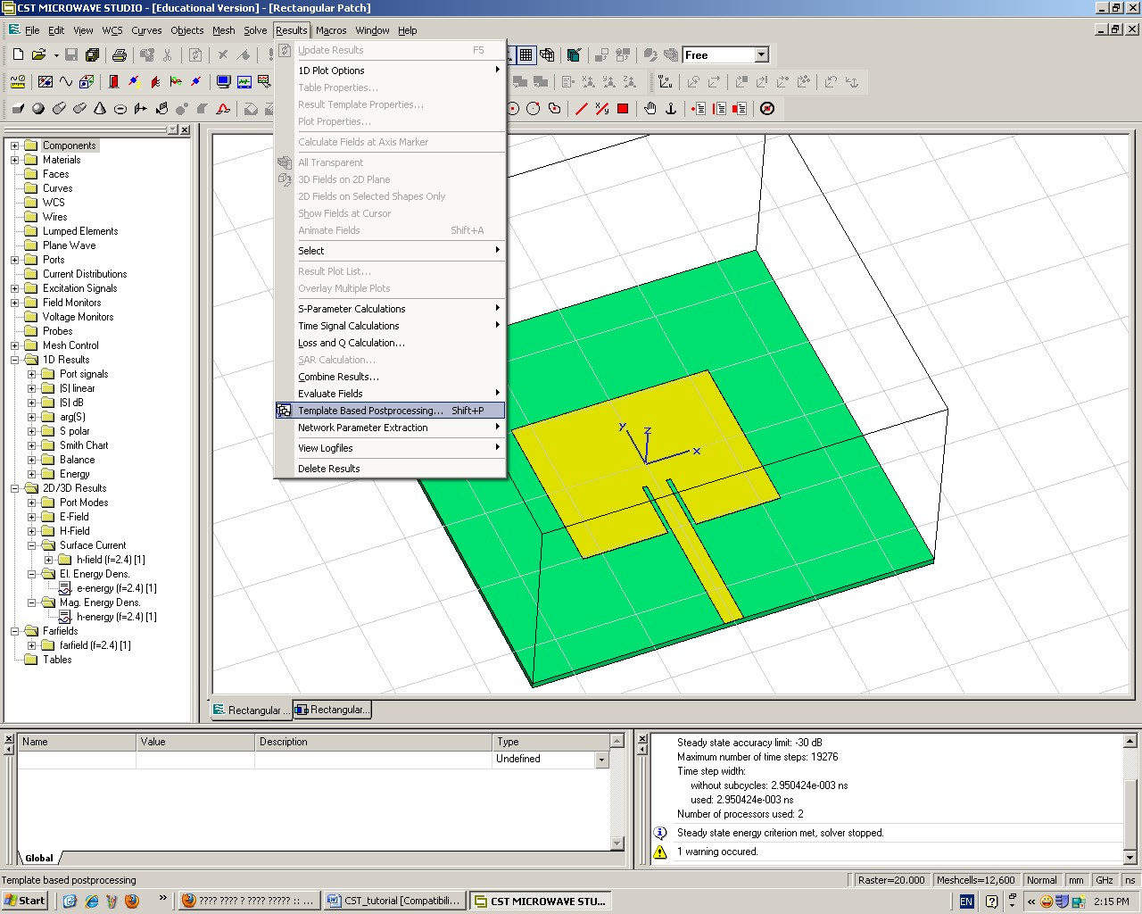

**Figure 3.26 Displaying the post processing results**

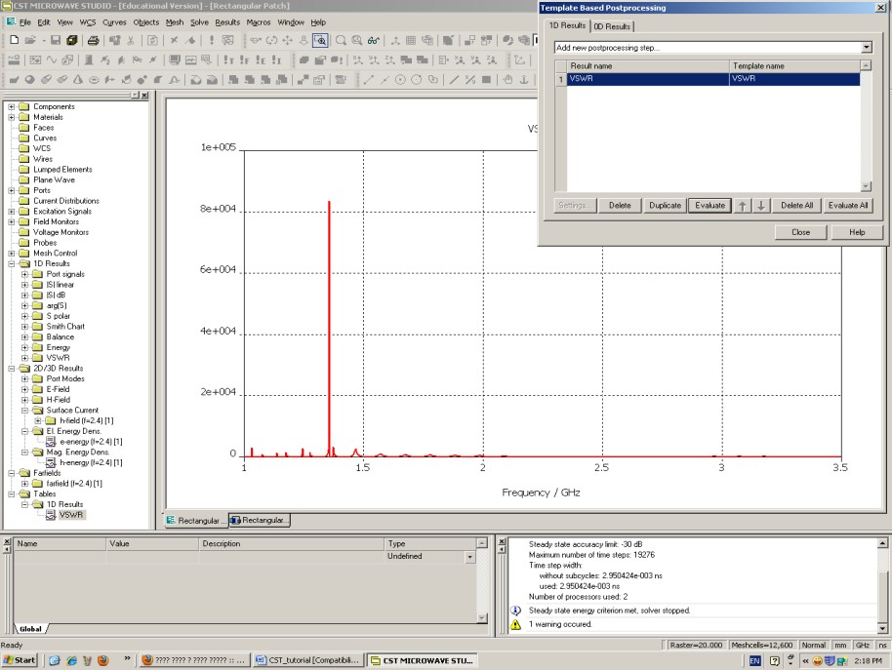

**Figure 3.27 Displaying the post processing results**

**Chapter 4**

**DESIGN AND SIMULATION**

**4.1 SUBSTRATE MATERIAL SELECION:**

In order to study the effect of substrate variation on the gain and efficiency, antennas were designed using the mentioned substrates at the same central frequency. Some geometric shape and substrate thickness was used in all designed prototypes in order to have a valid comparison for the parameters measured. The analysis was measured. The analysis was performed using the following materials and its properties are explained below.

**4.2 PROPERTIES OF DIELECTRIC SUBSTRATES:**

**(a)**BAKELITE

Bakelite are poly oxy benzyl methylene glycolan hydride, is an early plastic. It is a thermosetting phenol formaldehyde resin, formed from by elimination reaction of phenol with formaldehyde. It is most commonly used as an electrical insulator possessing considerable mechanical strength.

(b)FR-4 or (FR4) GLASS EPOXY

FR4 is a grade designation assigned to glass reinforced epoxy laminate sheets, tubes, rods and printed circuit boards. FR-4 is a composite material composed of woven fibre glass cloth with an epoxy resin binder that is flame resistant. FR-4 glass epoxy is a popular and versatile high-pressure thermo set plastic laminate grade with good strength to weight ratios. With near zero water absorption, FR-4 is most commonly used as an electrical insulator possessing considerable mechanical strength.

(c)RO4003

RO4003 Series High Frequency Circuit Materials are glass reinforced hydrocarbon/ceramic laminates(Not PTFE) designed for performance sensitive, high volume commercial applications. RO4000 laminates are designed to offer superior high frequency performance and low cost circuit fabrication. The result is a low loss material which can be fabricated using standard epoxy/glass (FR4) processes offered at competitive prices.

(d)TACONIC TLC

Taconic TLC substrates are specifically designed to meet the low cost objectives for newly emerging commercial RF/microwave applications. Taconic TLC substrates are manufactured in thickness .0145 (0.37mm) with excellent mechanical and thermal stability and cost less than traditional PTFE substrates.

(e)RT DUROID

RT Duroid is Glass Microfiber Reinforced PTFE (poly tetra fluro ethylene) composite produced by Roger Corporation. RT Duroid 5870 substrate has low loss tangent. They exhibit excellent chemical resistance, including solvent and reagents used in printing and plating, ease of fabrication – cutting, shearing, machining, environment friendly.

|  |  |  |  |  |  |
| --- | --- | --- | --- | --- | --- |
| **PARAMETERS** | **Bakelite** | **FR4 Glass Epoxy** | **RO4003** | **Taconic TLC** | **RT Duroid** |
| Dilelectric constant | 4.78 | 4.4 | 3.4 | 3.2 | 2.2 |
| Loss Tangent | 0.03045 | 0.013 | 0.002 | 0.002 | 0.0004 |
| Water absorption | 0.5-1.3% | <0.25% | 0.06% | <0.02% | <0.02% |
| Tensile Strength(MPa) | 60 | <310 | 141 | - | 450 |
| Volume Resistivity  (Mohm cm) | $$3 X {10}^{15}$$ | $$8 X {10}^{7}$$ | $$1700 X {10}^{7}$$ | $$1 X {10}^{7}$$ | $$2 X {10}^{7}$$ |
| Surface Resistivity(Mohm) | $$5 X {10}^{10}$$ | $$2 X {10}^{5}$$ | $$4.2 X {10}^{9}$$ | $$1 X {10}^{7}$$ | $$3 X {10}^{7}$$ |
| Density( $Kg/m^{3})$ | 1810 | 1850 | 1790 | - | 2200 |

**Table 4.1 properties of dielectric materials**

Dielectric constant of substrates affects the antenna performance. The substrate which has a low dielectric constant will give better performance than the substrate which has a high dielectric constant. Loss tangent of dissipation factor also plays a part in antenna performance. The high dielectric material allows for a reduction of space but at the cost of higher moisture absorption level.

Dielectric losses depend on the circuit configuration, dielectric constant, frequency and loss tangent. Dielectric constant and loss tangent vary with operating temperature changes and level of humidity, dielectric constant values usually vary between 0 and 0.05% over a ${100}^{0}$ c for most PTFE based laminates. Loss tangent or Dissipation factor can change significantly with moisture absorption as little as 0.25% of dielectric weight. Thus moisture absorption should be as low as possible.

Dielectric materials cannot resist indefinite amount of voltage, with enough voltage applied, any insulating material will succumb to electrical pressure and electron flow will occur. However, unlike the situation with conductors where the current is in a linear proportion to applied voltage(given a fixed resistance) current through an insulator is quite non-linear, for voltage below a certain threshold level, virtually no electrons will flow, but is the voltage exceeds that threshold, there will be a rush of current. Once current is forced through an insulating material, breakdown of that materials molecular structure has occurred. Hence volume resistivity and surface resistivity should be good. After breakdown, the material may or may not behave as an insulator any more, the molecular structure having been altered by the breach. There is usually a “puncture” of the insulating medium where the electrons flowed during breakdown. The breakdown voltage should be high. Thickness of an insulating material plays a role in determining its breakdown voltage, otherwise known as dielectric strength.

**4.3 Radar system:**

**Radar** is a detection system that uses radio waves to determine the range, angle, or velocity of objects. It can be used to detect aircraft, spacecraft, guided missiles, motor vehicles and weather formations. A radar system consists of a transmitter producing electromagnetic waves in the radio domain, a transmitting antenna, a receiving antenna (often the same antenna is used for transmitting and receiving) and a receiver and processor to determine properties of the object. Radio waves (pulsed or continuous) from the transmitter reflect off the object and return to the receiver, giving information about the object's location and speed.  Its acronym stands for **Radio Detection And Ranging**. The modern uses of radar are highly diverse, including air and terrestrial traffic control, air defence systems, anti-missile systems, marine radars to locate landmarks and other ships, aircraft anti-collision systems, ocean surveillance systems. Radar is a key technology that the self-driving systems are mainly designed to use, along with sonar and other sensors.

**4.4 Wi-Fi system:**

Wi-Fi is technology for radio wireless local area networking of devices based on the IEEE 802.11 standards. Devices that can use Wi-Fi technologies include desktops, laptops, video game consoles, smartphones, tablets , smart TVs, printers, digital cameras, cars and drones. Wi-Fi compatible devices can connect to the internet via a WLAN and wireless access point, such as an access point (or hotspot) for a range of about 20 metres (66 feet) indoors and a greater range outdoors. Hotspot coverage can be as small as a single room with walls that block radio waves, or as large as many square kilometres achieved by using multiple overlapping access points.

Different versions of Wi-Fi exist, with different ranges, radio bands and speeds. Wi-Fi most commonly uses the 2.4GHz(12 cm) UHF and 5GHz (6 cm) SHF ISM radio bands, these bands are subdivided into multiple channels. Each channel can be time shared by multiple networks. At close range, some versions of Wi-Fi running on suitable hardware can achieve speeds of over 1 Gbits/s.

**4.5 PROPOSED ANTENNA:**

Due to limitations in achieving high gain, directivity and wider bandwidth with regular shapes of patch such as rectangular and circular, hexagonal shaped microstrip antennas for a given frequency is designed. Also use of hexagonal patch antenna can support both linear and circular polarizations with the help of single feed. Certain modifications has been made to the previously designed rectangular patch to convert it into hexagonal patch. Using the same set of dimensions used in the above rectangular patch, polygons are marked on the co-ordinate axis on all four sides of the rectangular patch. These marked polygons are cut to get the final hexagonal structure. . 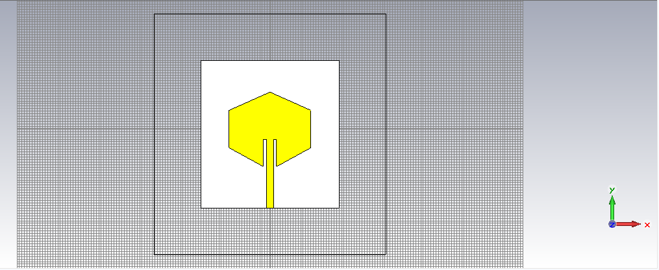 **Figure 4.1 Hexagonal Microstrip Patch Antenna without slots.**

**4.6 IMPLEMENTATION OF SLOTS:**

A slot is any cut or groove made on a flat metal sheet. Usually slots are introduced to a patch to improve the radiation pattern, gain and directivity. Cutting a slot in any patch antenna adds one or more additional resonating frequencies. The shape and size of the slot along with the driving frequency determines the radiation pattern of the patch. In this particular antenna slots are cut on the hexagonal patch which adds a resonating frequency at 5.25GHz. Further the size shape and position of slots are varied to achieve the resonating point at 3.05 and 5.25 GHz (ISM band). This improves the overall gain, bandwidth and directivity of the radiating patch. Here two slots are cut in the hexagonal patch making the patch resonate with return losses of -30 dB at 3.05 GHz and – 60 dB at 5.25 GHz.

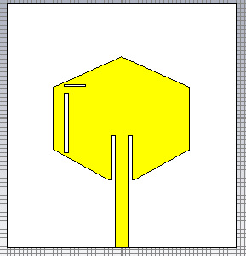

**Figure 4.2 Hexagonal Microstrip Patch Antenna with slots.**

**CHAPTER 5**

**RESULTS AND SIMULATION:**

The antenna is designed and simulated for the above mentioned value. Slots are added to achieve the desired resonating frequencies. The return loss and realized gain of the obtained resonating frequencies compared with that of the hexagonal antenna without slots is shown.

**5.1 GAIN PLOTS FOR HEXAGONAL ANTENNA WITHOUT SLOTS:**

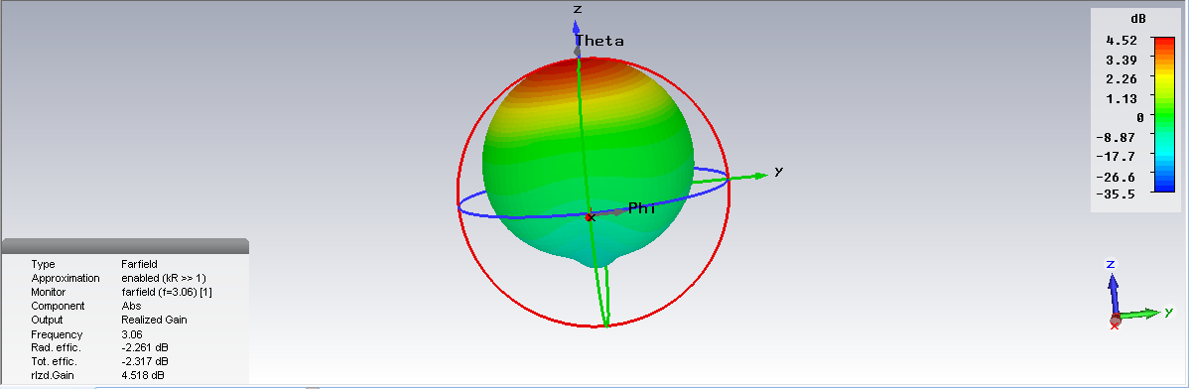

**Figure 5.1 Gain plot for hexagonal patch antenna without slots at 3.05GHz**

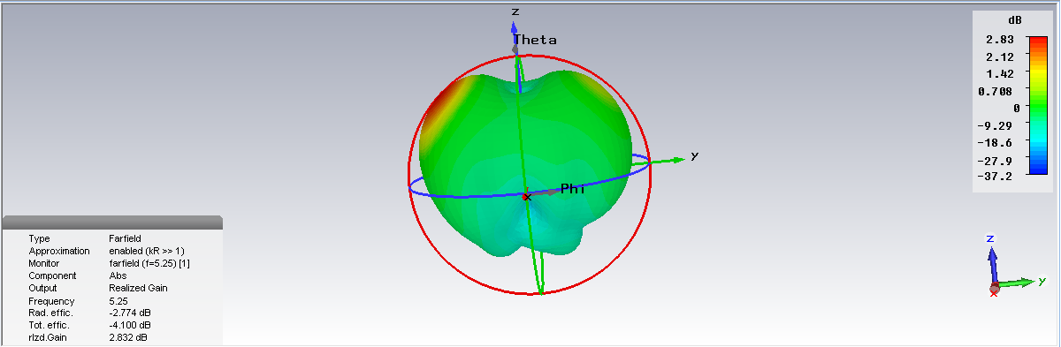

**Figure 5.2 Gain plot for hexagonal patch antenna without slots at 5.25GHz**

**5.2 GAIN PLOTS FOR HEXAGONAL MICROSTRIP PATCH ANTENNA WITH SLOTS:**

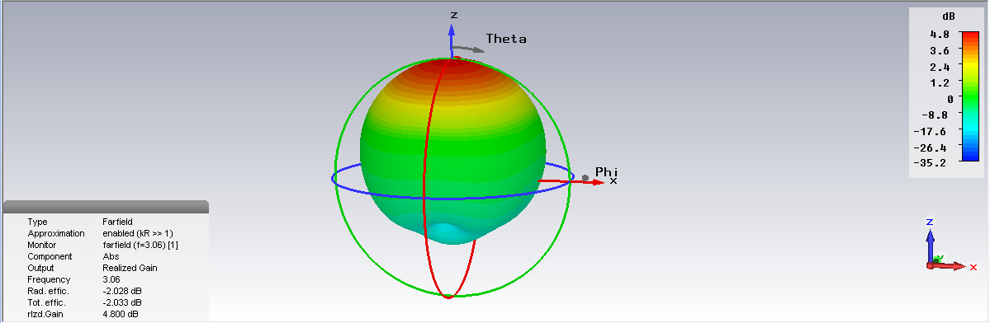

**Figure 5.3 Gain plot for slotted hexagonal patch antenna at 3.05GHz**

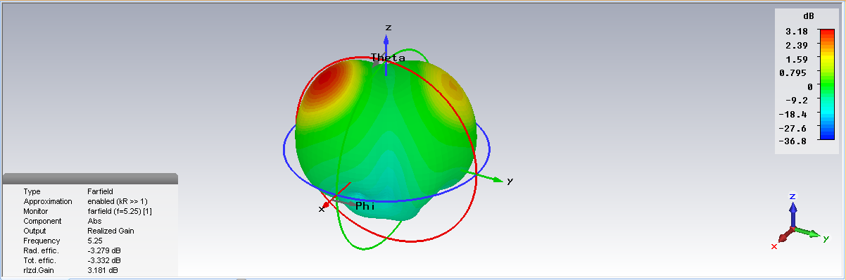

**Figure 5.4 Gain plot for slotted hexagonal patch antenna with at**

**5.25 GHz**

**5.3 RETURN LOSS:**

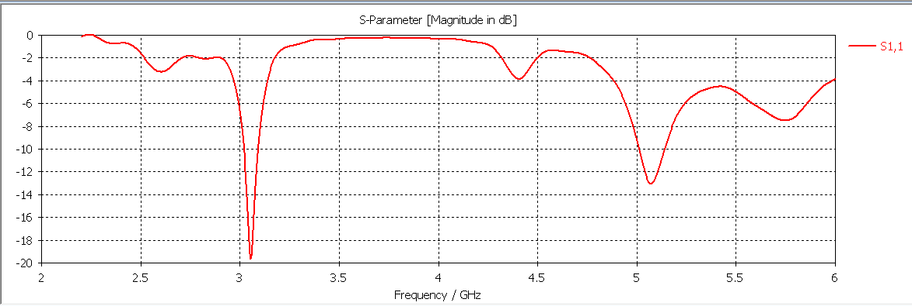

**Figure 5.5 Return loss of hexagonal microstrip patch antenna without slot**

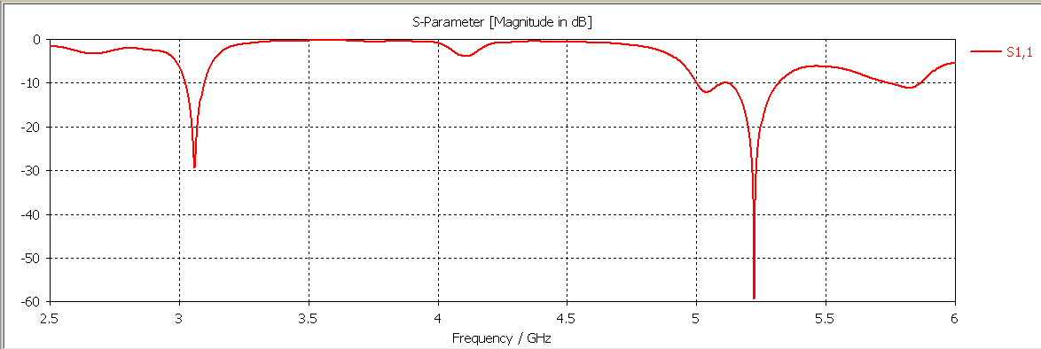

**Figure 5.6 Return loss of slotted hexagonal microstrip patch antenna**

**5.4 VSWR:**

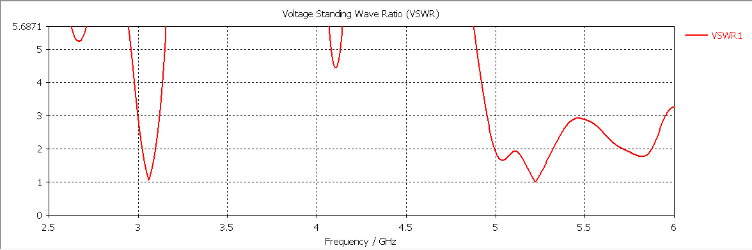

**Figure 5.7 VSWR of slotted hexagonal microstrip patch antenna.**

**5.6 DIRECTIVITY:**

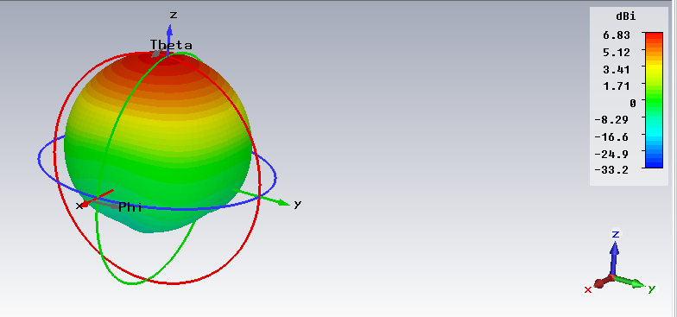

**Figure 5.8 Directivity of slotted hexagonal microstrip patch antenna at 3.05 GHz.**

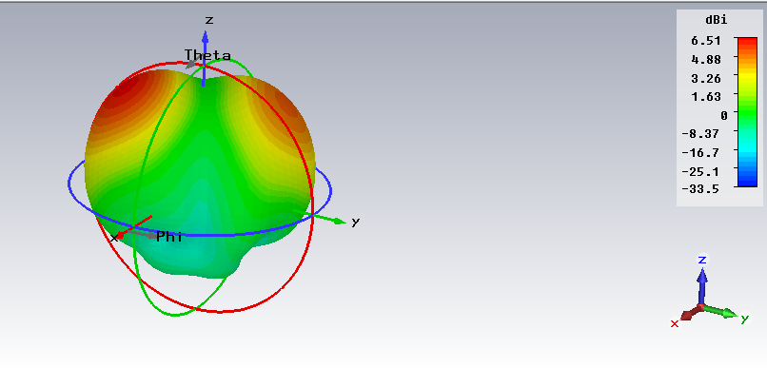

**Figure 5.9 Directivity of slotted hexagonal microstrip patch antenna at 5.25 GHz.**

|  |  |  |
| --- | --- | --- |
| **PARAMETER** | **3.05 GHz** | **5.25 GHz** |
| **Return loss** | **-29 dB** | **-59 dB** |
| **Gain** | **4.8 dB** | **3.18 dB** |
| **Directivity** | **6.83 dBi** | **6.51 dBi** |
| **VSWR** | **1.2** | **1** |

**Table 5.1 Parametric results of slotted hexagonal microstrip patch antenna**

**CHAPTER 6**

**CONCLUSION**

Therefore a dual band hexagonal microstrip patch antenna has been designed and simulated using CST MWS. It is observed that a return loss of

-29 dB at 3.05 GHz and -59 dB at 5.25 GHz with a gain of 4.8 dB and 3.18 dB respectively.

**CHAPTER 7**

**FUTURE WORK**

The future work relies on implementing an array structure for complex communication systems which improves overall gain, directivity and radiation pattern. The use of substrates with lower dielectric constant like Rogers and Duroid according to the requirement of the system.

**CHAPTER 8**

**REFERENCES**

[1] *Kadiyam Suresh. Dr. P. Siddaiah, “Design of Ku-Band Hexagonal Microstrip Patch Antenna With Linear and Circular Polarizations” vol. 3, Issue 4, April 2015.*

[2] *Vinita Mathur, Dr. Manisha Gupta, “Compariso of Performance Characteristics of Rectangular, Square and Hexagonal Microsrip Patch Antennas”, IEEE, 2014.*

[3] *M. L. Naidu, Dr. B. Rama Rao, Dr. C. Dharmaraj, “Implementation of Octagonal and Hexagonal Microstrip Patch Antennas for UWB Applications”, SSRG-IJECE, vol. 3, Issue 9 – September 2016.*

[4] *Alok Kumar, Nancy Gupta, P. C. Gautam, “Gain and Bandwidth Enhancement Techniques in Microstrip Patch Patch Antennas” International Journal of Computer Applications, vol. 148 – Np. 7, August 2016.*

[5] *Maneesh Rajput, “Design & Anlysis of Hexagonal Patch Antenna at 1.8GHz for L-Band”, vol. – 4, Issue – 3, June – 2014 ISSN No.: 2250-0758.*

[6] *Topas Mondal, “Compact Circularly Polarized Wide Beam Width Fern Fractal Shaped Microstrip Antenna for Vehicular Communication”. IEEE, 2018.*

[7] *Manoj Kumar, “Hexagonal Microstrip Patch Antenna to Operate in Dual Frequency Mode”, IJSRD, vol. 3, Issue 04, 2015.*

[8] *S. Anusha, “Hexagonal Shaped Micro-Strip Patch Antenna for Wi-Fi Application”, IJIRCCE, vol. 5, Issue 3, March 2017.*

[9] *Kalpana Muvalla, “Design and Analysis of Various Slots on Hexagonal Boundary Patch Antennas for Enhanced Gain”, DOI: 10.1007/978-981-10-4280-5_7, January 2018.*

**APPENDIX - I**

**PUBLICATIONS**

1 R.Kousik, V.Paavana Krishna, S. Dinesh, “**DUAL BAND HEXAGONAL MICROSTRIP PATCH ANTENNA FOR RADAR AND WIFI APPLICATIONS**” in the **7th International Conference on Contemporary Engineering And Technology 2019** organized by **Organization of Science & Innovative Engineering And Technology (OSIET), Chennai, India.** In association with **Prince Shri Venkateshwara Padmavathy Engineering College, Prince Dr. K Vasudevan College of Engineering & Technology.**